**Special Notes:**

1. Use the following format for your database name: **PC_[PARTICIPANT ID]**, example: **PC_01** or **PC_10**.
2. You must submit the **SQL** **file** of your database schema. Make sure to also generate script for the record insertion process.
3. In the event you fail to submit the proper file that causing your submission cannot be run, no score will be given.
4. You are not allowed to modify or alter the structure of the given database.

Mandheg Parking System

**Mandheg Parking System** is a new application aimed to help manage parking system in several shops. As the newly appointed developer, you are tasked to create the Database schema using Microsoft SQL Server. Given along the projects are Entity Relationship Diagram and an Excel file containing Data Dictionary and Records for the Database. You must first create the database, then import all records given into the database. After that generate an **SQL** **File** that contains both database schema and its records.

# **Entity Relationship Diagram (ERD)**

The following is the ERD of **Mandheg Parking System**.

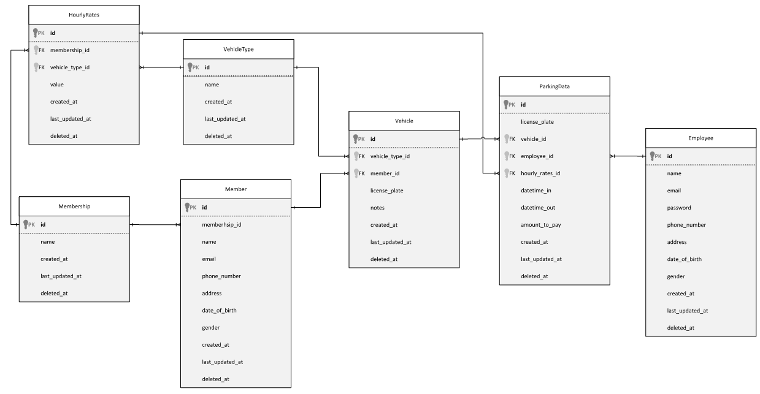

**Figure 1. ERD of Mandheg Parking System**

# **Data Dictionary**

Please check **“Dataset.xlsx”** file.